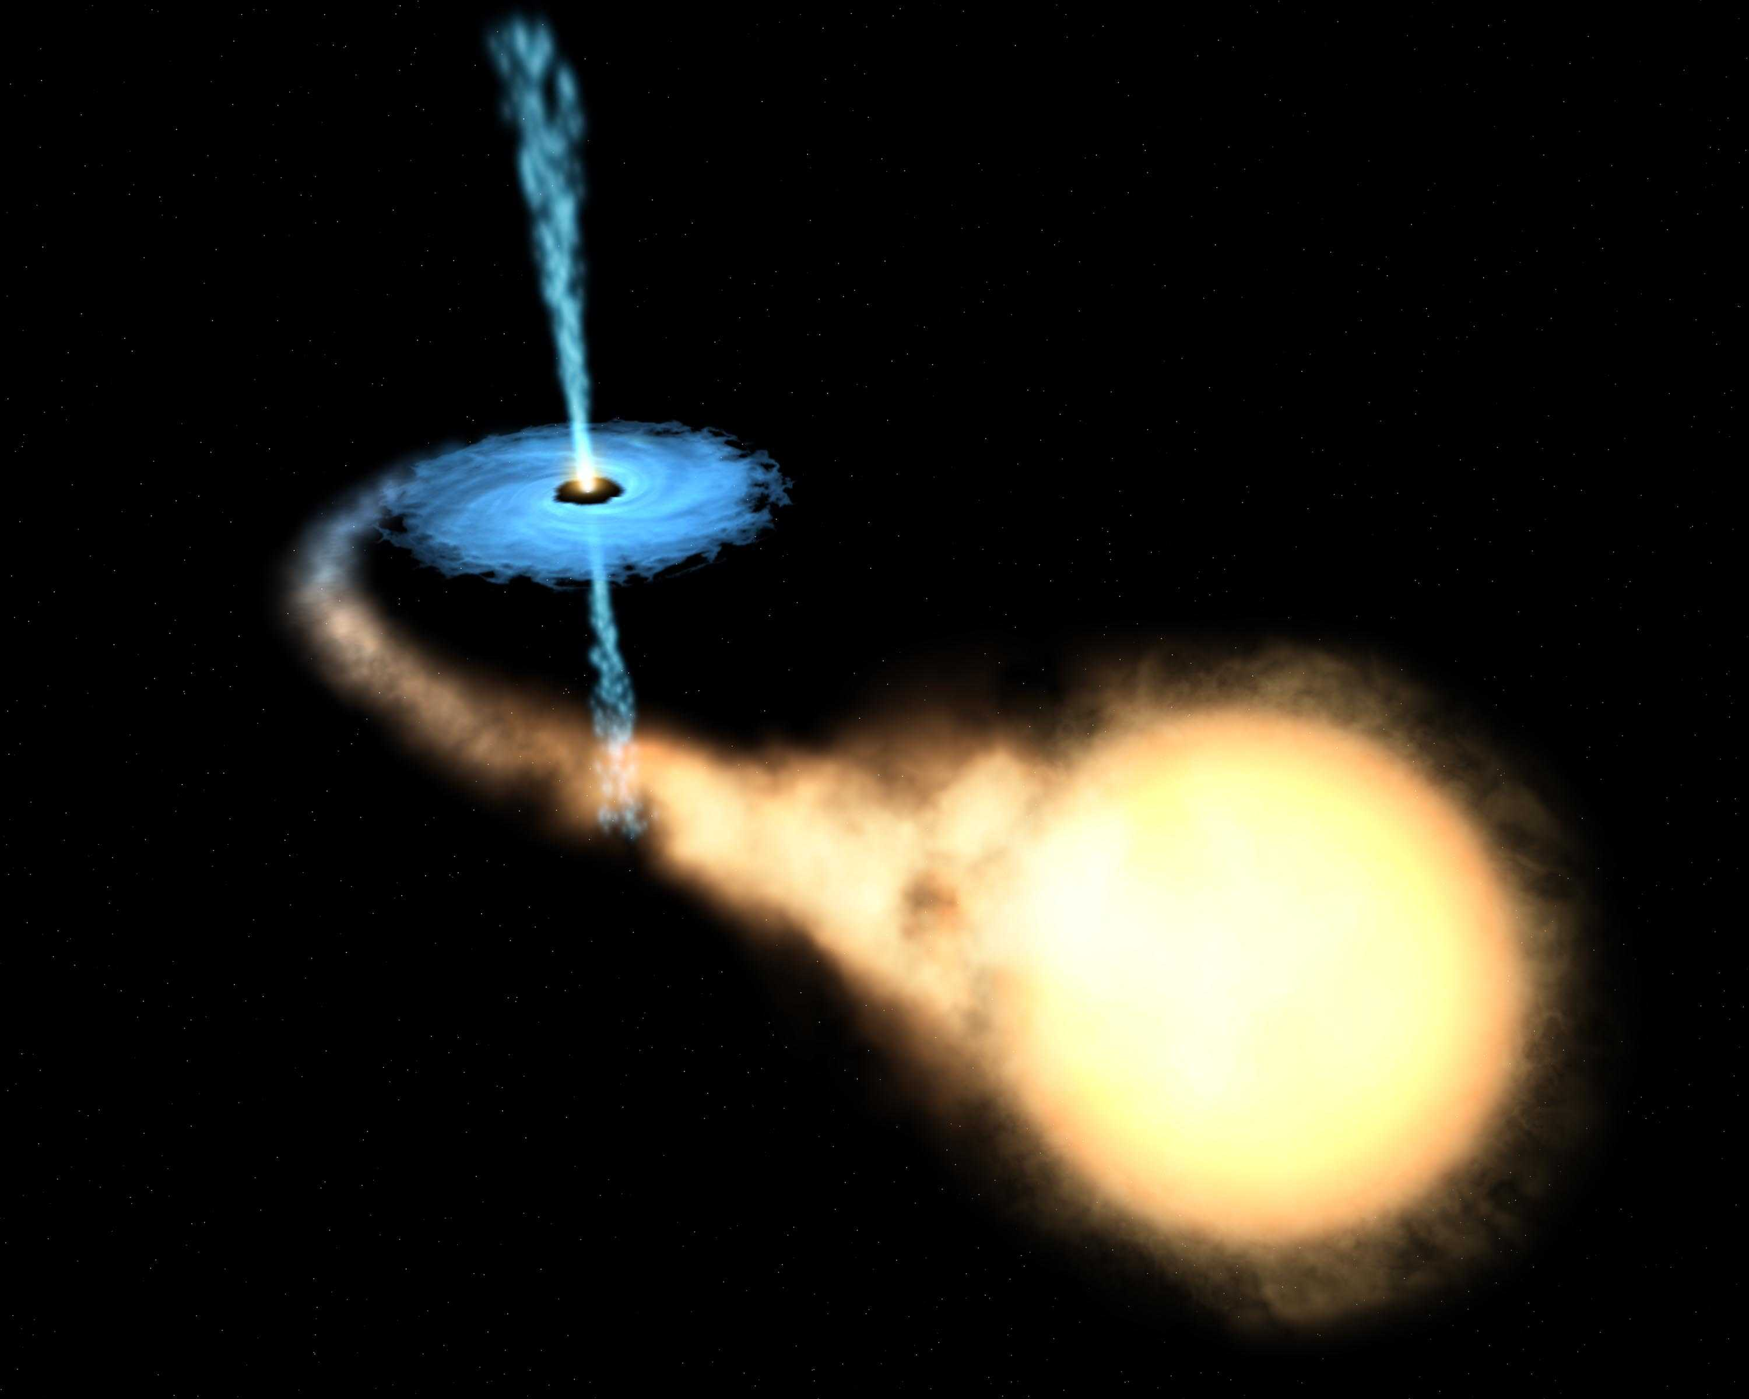
3rd Form
Physics
Time and Space

Name:

Form:

Physics Teacher:

Reigate Grammar School

Introduction

Welcome to studying Physics in the Third Form.

In this, the first half of the Autumn term, we start the IGCSE course by studying the concepts of Time and Space; this is an introduction to our galaxy, solar system and gravity. It’s a great opportunity for you to ask questions about the Universe and how we come to understand the timeline of events from creation to the present.

The sections of the syllabus covered are:
1.15 recall and use the relationship between weight, mass and g:
weight = mass × g
W = m × g
1.30 recall that the Moon orbits the Earth and that some planets also have moons.
1.31 understand gravitational field strength, g, and recall that it is different on other planets and the Moon from that on the Earth.
1.32 explain that gravitational force
− causes the planets to orbit the Sun
− causes the Moon and artificial satellites to orbit the Earth
− causes comets to orbit the Sun
1.34 describe how the orbit of a comet differs from that of a planet
1.35 recall that the solar system is part of the Milky Way galaxy
− describe a galaxy as a large collection of billions of stars
− state that the Universe is a large collection of billions of galaxies.

This booklet contains:
- laboratory rules
- Physics VIPs and word commands
- lesson worksheets
- potential homework and extension work
- end of topic revision sheet

RGS – Science Department – Laboratory Rules

The Health and Safety at Work Act holds teachers and pupils responsible for their actions if others are harmed by them.

The biggest danger in the laboratory is YOU!
You are a danger whenever you are either thoughtless or careless or both.
Remember this, because the person most likely to suffer from your mistakes is YOU!

1. You should only go into a lab if you have permission to do so from a teacher.

2. You must wear eye protection when told to do so and at all times during Chemistry practical work and keep it on until all practical work (including tidying up) is finished.

3. Long hair must be tied back and loose garments (ties) should be tucked in before any experiment.

4. Never put anything in your mouth (food or drink) in the lab. This includes fingers and pencils.

5. You must not be seated during experimental work, unless you are specifically told to do so by your teacher.

6. If you are not sure of what you are supposed to do during a practical ASK for help.

7. Don’t touch apparatus, electrical equipment or chemicals (or gas taps, water taps and electricity supplies) unless you have been told to do so.

8. When heating substances, use small amounts and take care not to point test tubes at yourself or anybody else, and never look directly down a test tube.

9. Only place hot objects on a heat proof mat using appropriate apparatus.
Allow hot equipment or substances to cool before you touch them, store them or throw them away.

10. If you get burnt, or get chemicals on your skin, immediately wash the affected part with lots of cold water and alert your teacher.

11. Report ANY accident, however slight (including breakages and spillages), to your teacher.

12. Waste, or surplus, materials should be disposed of as instructed by your teacher.
DON’T throw solids into sinks.

13. Keep your bench clean and tidy. Make sure it is wiped clean at the end of any experiment.

14. Wash your hands after laboratory work; this is especially important before meals.

- Apparatus and chemicals must NEVER be removed from a lab.

ANY INAPPROPRIATE OR DANGEROUS BEHAVIOUR WILL RESULT IN EXCLUSION FROM PRACTICAL ACTIVITIES.

Physics VIPs
The basics
- All work must have an underlined title
- All work should be dated
- All books should be kept neat
- Notes and practical work are written in this booklet, homework and rough working go in the soft-back book

Tables
- If you have more than one table, identify what the data is
- Include a unit in your column headers
- Keep the number of decimals in each column constant
- Tables should be drawn with a pencil and ruler

Answering questions
- Show the formula you have used
- Show all of your working
- If your page contains lots of calculations, then underline the answer to highlight it
- Answers must have units
- Use the correct scientific terms where possible e.g. atom, nucleus

Word Commands
• Calculate – students may be asked to perform calculations.
• Compare – students should offer similarities and differences between the items being compared. This should not be answered by writing two paragraphs that deal separately with the two items.
• Describe – students should offer a response that includes the fundamental facts about the item or process for which the description is requested.
• Design – students may be asked to design an experiment.
• Explain – students should offer a response that utilises the underlying principles and concepts involved.
• Name – students should offer the name of the object or process in question. They should not describe or explain it.
• Plot/draw/complete/measure – students may be asked questions requiring them to plot data, draw diagrams, complete tables or measure drawn apparatus.
• State/identify – students should offer a concise response with no explanation unless this is also requested.
• Suggest – students will be expected to offer a logical response, not based on recall of knowledge, but on applying the principles and concepts gained during the course. This may be related to new situations or may relate to familiar situations in which there is no single correct response.
Gravity Cans
What is the equation that links weight, mass and gravitational field strength?
Measure and record the weight of each can in the table below. Using the weight of each can and the ‘mass of each can’ (they are all the same), work out the strength of the gravitational field/g of each planet
Planet | Weight (N) | Mass (kg) | Gravitational field strength (N/kg)
Pluto
Mars
Mercury
Venus
Uranus
Earth
Saturn
Neptune
Jupiter

Use the space below for your working.
The table below lists the planets and their relative gravitational field strength to Earth.
Planet | Relative strength of gravitational field /g
Mercury | 0.377
Venus | 0.904
Earth | 1.000
Mars | 0.377
Jupiter | 2.535
Saturn | 1.060
Uranus | 0.904
Neptune | 1.140
Pluto | 0.062
Your task is to match the planet with their symbol using their relative gravitational field strength.
Symbol on can | Planet
♀ | Venus
♅ | Uranus
♆ | Neptune
♁ | Earth
♄ | Saturn
♇ | Pluto
☿ | Mercury
♃ | Jupiter
♂ | Mars

scale model of the solar system
Raw Data
Body | Mean Diameter (km) | Mean Radius of orbit (km)
Sun | 1392000 | Not applicable
Mercury | 4879 | 58343220
Venus | 12102 | 107710560
Earth | 12742 | 149598000
Mars | 6792 | 227388960
Jupiter | 142984 | 777909600
Saturn | 120536 | 1427164920
Uranus | 51118 | 2875273560
Neptune | 49528 | 4496915880
Pluto | 2390 | 5906129040
Scale Model
You should calculate scale diameters and orbital radii using the information provided.
If the Sun goes from 1392000km to 1m on the scale, then the scale factor is ¹⁄₁₃₉₂₀₀₀₀₀₀. To find the scaled diameter of the Earth you must multiply its existing size by the scale factor: i.e. 12742000 × ¹⁄₁₃₉₂₀₀₀₀₀₀ = 0.00915m = 9.15mm
Body | Scale diameter (m) | Scale radius of orbit (m)
Sun | 1 | Not applicable
Mercury
Venus
Earth | 0.009 | 2.53
Mars
Jupiter
Saturn
Uranus
Neptune
Pluto |  | 100

big bang timeline
Fill in the boxes for each stage in the evolution of the Universe. You can use any information that you can find and can include diagrams.
 |  | Quarks |  |  |  |  |  |  | Atoms |  |  |  |  |  |  | Galaxies |  |  |  |  |  | Human Beings
Big Bang |  |  |  |  | Protons and Neutrons |  |  |  |  |  |  | Stars |  |  |  |  |  |  | Solar System |  |  |  |  |  |  | Today

powers of 10
Multiples
Prefix | Symbol | Multiplier | Example
hecto~ | h | 100 | hectopascal (hPa)
kilo~ | k | 1000 | kilogram (kg)
mega~ | M | 1 000 000 | megabyte (Mb)
giga~ | G | 1 000 000 000 | gigabyte (Gb)
tera~ | T | 1 000 000 000 000 | terahertz (THz)
Submultiples
Prefix | Symbol | Multiplier | Example
centi~ | c | 0.01 | centimetre (cm)
milli~ | m | 0.001 | millimetre (mm)
micro~ | µ | 0.000 001 | microsecond (µs)
nano~ | n | 0.000 000 001 | nanometre (nm)
pico~ | p | 0.000 000 000 001 | picolitre (pl)
Questions
1000 | grams | = |  | kilograms
20 000 | hertz | = |  | kilohertz
1 | gigabyte | = |  | bytes
10 | milliseconds |  |  | seconds
600 | microseconds | = |  | seconds
0.6 | megametres | = |  | kilometres
2000 | nanometres | = |  | Millimetres
100 | centimetres | = |  | millimetres
1 | day | = |  | seconds

Use the space below for your working.
Standard Form
On the previous Powers of 10 sheet you will notice that there are lots and lots of zeroes. Because scientists and mathematicians are far too important to spend all their time writing out long strings of zeroes they use a special system for writing very large or very small numbers which is called standard form (sometimes also known as scientific notation).
For example: the speed of light in a vacuum is 299,800,000m/s. This can be written in standard form as 2.998 × 10⁸ m/s. The first part, 2.998, is called the significand and contains the significant digits; it is always greater than 0 and less than 10. The second part, 10⁸, is the multiplier and indicates how big the number is.
Long Form | Standard Form | Long Form | Standard Form
1 | 1 × 10⁰ | 1 | 1 × 10⁰
10 | 1 × 10¹ | 0.1 | 1 × 10⁻¹
100 | 1 × 10² | 0.01 | 1 × 10⁻²
1 000 | 1 × 10³ | 0.001 | 1 × 10⁻³
10 000 | 1 × 10⁴ | 0.000 1 | 1 × 10⁻⁴
100 000 | 1 × 10⁵ | 0.000 01 | 1 × 10⁻⁵
1 000 000 | 1 × 10⁶ | 0.000 001 | 1 × 10⁻⁶
Questions
Long Form | Standard Form
 | 9.46×10¹⁵
 | 3.08×10¹⁶
 | 6.67×10⁻¹¹
101 000
0.0254
149 000 000 000
4 500 000 000
0.000 002 18

What is the Time?
Chronometry
In the power point presentation you have been shown six ways to measure time:
1
2
3
4
5
6

In your groups you are to research.................................. in the library, making notes in your note book. At the end of the lesson you will be expected, as a group, to present your findings in a 2 minute talk. Your talk must include details of:
- How it works
- Developments
- Advantages and disadvantages
- Future developments
- In your note books, you will make notes on all of the groups’ talks.
In the space below write notes on what you are going to say during your talk.

Chronometry talk evaluation forms
Group’s clock |  | Group’s clock |  | Group’s clock
Pupils |  | Pupils |  | Pupils

Did you understand how the clock works? Comment:  Score /5 | Did you understand how the clock works? Comment:  Score /5 | Did you understand how the clock works? Comment:  Score /5
Did you hear about any developments past and present? Comment:  Score /5 | Did you hear about any developments past and present? Comment:  Score /5 | Did you hear about any developments past and present? Comment:  Score /5
Advantages and disadvantages? Comment:  Score /5 | Advantages and disadvantages? Comment:  Score /5 | Advantages and disadvantages? Comment:  Score /5
Was the talk clear? Comment:  Score /5 | Was the talk clear? Comment:  Score /5 | Was the talk clear? Comment:  Score /5
Chronometry talk evaluation forms
Group’s clock |  | Group’s clock |  | Group’s clock
Pupils |  | Pupils |  | Pupils

Did you understand how the clock works? Comment:  Score /5 | Did you understand how the clock works? Comment:  Score /5 | Did you understand how the clock works? Comment:  Score /5
Did you hear about any developments past and present? Comment:  Score /5 | Did you hear about any developments past and present? Comment:  Score /5 | Did you hear about any developments past and present? Comment:  Score /5
Advantages and disadvantages? Comment:  Score /5 | Advantages and disadvantages? Comment:  Score /5 | Advantages and disadvantages? Comment:  Score /5
Was the talk clear? Comment:  Score /5 | Was the talk clear? Comment:  Score /5 | Was the talk clear? Comment:  Score /5

Are you alert?

Introduction

Get into pairs.
Get your partner to hold a fake fiver as shown, just above your finger and thumb.
Without warning, they are to drop the fiver and you must catch it.

See if you get any better with practice.
Try the experiment again, this time counting down from 10,000, out aloud. See how much more difficult it is to catch the fiver. (Apparently, counting down from 10,000 requires a similar concentration level to having a normal conversation.)
Swap with your partner. Who’s got faster reactions?

What factors might affect your reaction time? List a few here:

Does it matter how heavy the dropped object is? What if we used a cardboard ‘fiver’?

We really need a reaction timer that actually measures how fast your reactions are, one that gives us a quantitative measurement.

Making a reaction timer
A ruler is going to be used as the object to be dropped. First we must calibrate it to show what times the various distances are equivalent to.
Stick a strip of masking tape all the way down the ruler on the flat side.
Calculate the time represented by each 5 cm marking using the following formula:

Time =  {(2 x distance in metres)  9.81}

Eg. for 5 cm: time = √ {(2 x 0.05) ÷ 9.81} = 0.100963755
So, the 5 cm position represents 0.10 seconds (to 2 d.p.)

Fill in this table with the times represented by every 5 cm along the ruler. Ask your teacher if you need any help.

Distance (cm) | Time (s) (2 d.p)
0 | 0.00
5 | 0.10

Write the times in pencil on the masking tape.
Now try out your reaction timer on your partner, dropping it from just above their fingers. Measure to the top of where their fingers catch the ruler.

Results:

Average reaction time for (name):__________________ = ________s
My own average reaction time = ________s

what if earth was a cube?
The Earth, and all the other planets, are spheres.
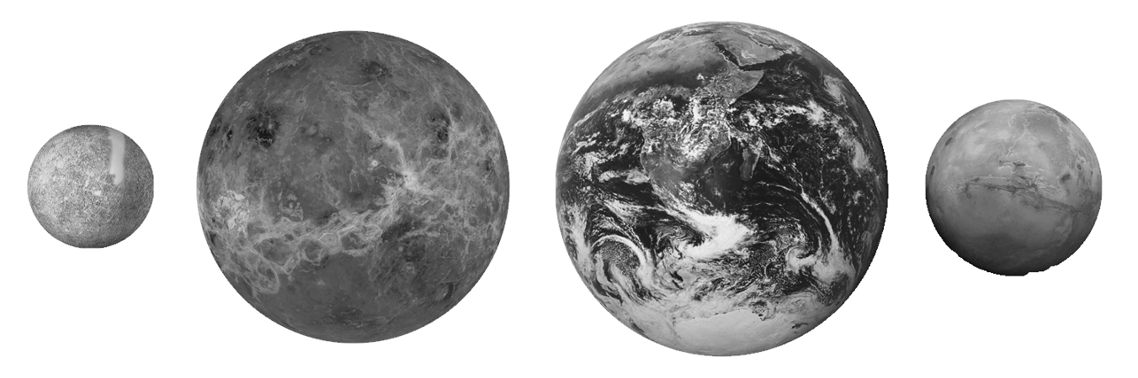
This is because the planets are so massive that their enormous gravitational field crushes them evenly from every direction until all the bumps have been evened out and a sphere is produced.
Because Earth is a sphere you feel the same force of gravity no matter where you are – you don't weigh anymore in Sydney than you do in London.
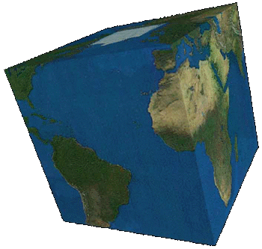
What would life be like if Earth was a cube?
Remember that gravity always acts towards the centre of a planet and that the strength of gravity depends on how far from the centre you are.
If Earth was a cube …

escape velocity
Objects trying to leave a planet must reach a certain speed in order to leave the planet's gravity; this is called the escape velocity.

The escape velocity depends on the gravity of the planet; and the gravity of the planet depends on its mass and its size.
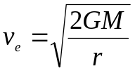
where v_{e} is escape velocity; G is the gravitational constant (6.67×10⁻¹¹); M is the mass of the planet in question; and r is the radius of the planet.
Body | Mass (kg) | Radius (m)
Earth | 5.97×10²⁴ | X6 371 000
Moon | 7.35×10²² | X1 737 000
Mercury | 3.30×10²³ | X2 440 000
Jupiter | 1.90×10²⁷ | 71 492 000
Uranus | 8.68×10²⁵ | 25 362 000
Pluto | 1.31×10²² | X1 195 000
a) Calculate the escape velocity on Earth. Your answer should be approximately 11 200m/s.
11181m/s
- If one mile is 1609m and one hour is 3600s, what is the escape velocity of Earth in miles per hour?
25000mph
c) Calculate the escape velocity for the other planets in metres per second.

multiples and submultiples
In science it’s sometimes not convenient to use standard units like the metre. It’s sometimes more suitable to use multiples or submultiples to make standard units bigger (e.g. kilometre) or smaller (e.g. centimetre).

Multiples
Make units bigger
Multiplier |  | Name | Prefix
10 | ten | deca~ | da
100 | hundred | hecto~ | h
1 000 | thousand | kilo~ | k
1 000 000 | million | mega~ | M
1 000 000 000 | billion | giga~ | G
1 000 000 000 000 | trillion | tera~ | T
1 000 000 000 000 000 | quadrillion | peta~ | P

Submultiples
Make units smaller
Multiplier |  | Name | Prefix
1/10 | tenth | deci~ | d
1/100 | hundredth | centi~ | c
1/1 000 | thousandth | milli~ | m
1/1 000 000 | millionth | micro~ | µ
1/1 000 000 000 | billionth | nano~ | n
1/1 000 000 000 000 | trillionth | pico~ | p
1/1 000 000 000 000 000 | quadrillionth | femto~ | f

Use the table to answer the questions. The first one has been done for you.

One million trons |  | megatron
One million phones |  | megaphone
One millionth of a wave |  | microwave
One thousandth of an onaire |  | millionaire
One hundredth of a pede |  | centipede
One hundredth of a mental |  | centimental
One trillion bulls |  | terabull
One tenth of a bel |  | decibel
One trillion wrists |  | terawrist
One millionth of a scope |  | microscope
One quadrillion andrés |  | petaandré
One trillion dactyls |  | teradactyl
One trillionth of a boo |  | picoboo
One thousand whales |  | kilowhale
One thousandth of an enium |  | millienium
Ten cards |  | decacards
One trillionth of a choo |  | picochoo
One quadrillion rols |  | petarol
One hundred r |  | hector
Ten de |  | decade
One trillionth of a ngduck |  | picongduck
Two thousand mockingbirds |  | two kilomockingbird

gravitation
 | W | A |  | U | O
 | E | S |  | N | R |  | P
 | I | T | M | I | B |  | H
 | G | R | A | V | I | T | Y
 | H | O | S | E | T | H | S
 | T | N | S | R |  | E | I
 |  | O |  | S |  | O | C
 |  | M |  | E |  | R | S
 |  | Y |  |  |  | Y

Gravity causes objects to have | W | E | I | G | H | T | .

A | S | T | R | O | N | O | M | Y | is the study of space.

Gravity acts on objects that have | M | A | S | S | .

The | U | N | I | V | E | R | S | E | is everything that physically exists.

Gravity causes planets and moons to | O | R | B | I | T | .

Isaac Newton set out his | T | H | E | O | R | Y | of gravitation in 1687.

Gravity is one of the most important topics in | P | H | Y | S | I | C | S | .

THINKING DISTANCE and Stopping Distance

Introduction
Use the web site http://www.gcse.com/fm/stopping_distances.htm to answer the following questions; move from one page to the next:

- What is the thinking distance?
- What four factors affect your thinking time and how do they affect it?
- Pick two factors that affect your braking distance. Explain how they can have a detrimental affect on your braking distance.
- Using the table of ‘thinking distance’, what is the thinking distance at 55 mph? Showing your working, what is the reaction time of the driver travelling at 20 mph?
- How do you calculate the stopping distance?
- From the graphs, what is the greater factor affecting the stopping distance at 10 mph and then again at 70 mph?

Revision sheet

The following points identify the ideas and concepts that you have learnt in the Time and Space topic:
- Pupils can define weight as the force on an object due to its mass; W=mg.
- Pupils can describe qualitatively the effect of changing distance and masses on the strength of a gravitational force .
- Pupils can identify that the pull of gravity is the reason why planets and comets orbit stars.
- Pupils can name the major features of the solar system.
- Pupils can describe the path of inner and outer planets and how they differ from comets.
- Pupils can explain the causes of seasons and tides.
- Pupils can outline a description of the Big Bang, nucleosynthesis and planet formation.
- Pupils can use the standard form and symbols for orders of magnitude (c, k, M, G and m, μ, n).
- Pupils can recall an overview of the history of chronometry.
- Pupils can identify major advantages and disadvantages of several types of clock.
- Pupils can explain how a sundial is used to measure time.
- Pupils understand the concept of reaction time, the factors that affect it and can recall one way of measuring reaction time.

For your revision, you should be using the notes made in class along with your text book; the following pages may be useful 10-11, 42-43 & 280-281. You should make summary notes, test one-another, make up your own questions to test each other and review homework.

