what if earth was a cube?
The Earth, and all the other planets, are spheres.
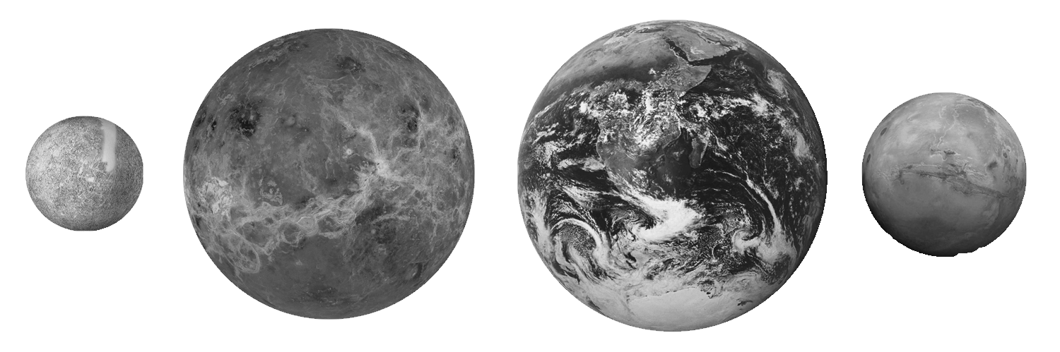
This is because the planets are so massive that their enormous gravitational field crushes them evenly from every direction until all the bumps have been evened out and a sphere is produced.
Because Earth is a sphere you feel the same force of gravity no matter where you are – you don't weigh anymore in Sydney than you do in London.
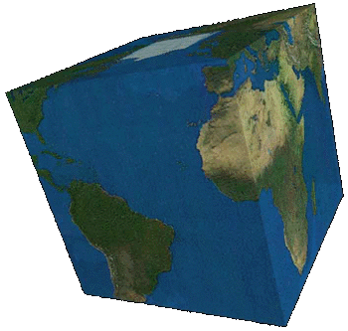
What would life be like if Earth was a cube?
Remember that gravity always acts towards the centre of a planet and that the strength of gravity depends on how far from the centre you are.
If Earth was a cube …

